**Name:** SCHAFT

**Created On:** 02-Jul-21 8:14:20 PM

**Created By:** HEIDER

**Modified On:** 25-Feb-22 7:18:29 AM

**Modified By:** HEIDER

**Size:** 573 KB

¶1: **Startup Failure Post-Mortems 2019 Second Update (6/19/2019)**

### ¶2: SCHAFT

¶3: Title: [Google parent to pull plug on bipedal robot development](https://asia.nikkei.com/Business/Companies/Google-parent-to-pull-plug-on-bipedal-robot-development)

¶4: Title Link: <https://asia.nikkei.com/Business/Companies/Google-parent-to-pull-plug-on-bipedal-robot-development>

¶5: Product: [SCHAFT](https://www.cbinsights.com/company/schaft)

¶6: Produc Link: <https://www.cbinsights.com/company/schaft>

¶7: The [Google-owned](https://www.cbinsights.com/investor/google) robotics unit has been shut down:

¶8: Following Softbank’s decision not to move forward with the Schaft acquisition,” an Alphabet spokesperson told Nikkei, “we explored many options but ultimately decided to wind down Schaft. We’re working with employees to help them find jobs elsewhere within or outside of Alphabet.

# ¶9: SCHAFT

¶10: INDUSTRIAL | Machinery & Equipment / Robotics

¶11: [schaft-inc.jp](https://schaft-inc.jp/)

## **¶12:** Founded Year

¶13: 2012

## **¶14:** Stage

¶15: Dead | Dead

## **¶16:** About SCHAFT

¶17: SCHAFT was born in 2012 as a spin-out company from the JSK Laboratory of the University of Tokyo, Graduate School of Information Science and Technology, providing high-power humanoid robots for dirty dangerous and difficult work, and for research purpose.

## **¶18:** SCHAFT Headquarter Location

¶19: Tokyo, Japan

# ¶20: **Google parent to pull plug on bipedal robot development**

¶21: **KAZUYUKI OKUDAIRA, Nikkei senior staff writer**November 14, 2018 14:21 JST   
¶22: Link: <https://asia.nikkei.com/Business/Companies/Google-parent-to-pull-plug-on-bipedal-robot-development>  
¶23: Tokyo-born unit Schaft lost its way after departure of robot chief Andy Rubin

¶24: 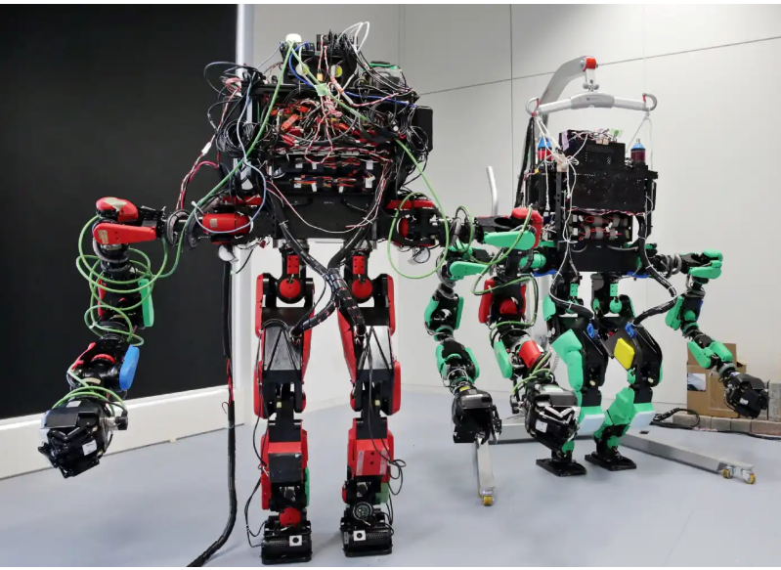

¶25: Bipedal robots developed by Schaft are designed to save human lives at disaster sites.

¶26: TOKYO -- Alphabet, the holding company behind Google, will cease development of bipedal robots, giving up on the prospect of early commercialization. The company is expected to dissolve the project later this year and relocate employees involved in development to other departments within Alphabet or help them find jobs elsewhere.

¶27: Google entered the robotics business in 2013 by buying Schaft, a tech startup founded by University of Tokyo researchers, and other companies. But the company scaled back the business, due in part to the departure of Andy Rubin in 2014, who has led the robotics business.

¶28: [SoftBank Group](https://asia.nikkei.com/Companies/SoftBank-Group-Corp) in June 2017 announced that it had agreed with Alphabet to purchase Schaft, but one or more Schaft employees refused to be part of SoftBank, according to people familiar with the matter. SoftBank’s attempt to buy Schaft apparently broke down.

¶29: “Following Softbank’s decision not to move forward with the Schaft acquisition,” an Alphabet spokesperson told Nikkei, "we explored many options but ultimately decided to wind down Schaft. We’re working with employees to help them find jobs elsewhere within or outside of Alphabet."

¶30: Yuto Nakanishi, assistant professor of the University of Tokyo, and others established Schaft in 2012. The startup has developed bipedal robots, which can be used to save human lives at disaster sites.

¶31: Schaft couldn’t find investors to provide growth capital in Japan and asked Google for help. The company won first place in a robot technology contest hosted by the U.S. Department of Defense immediately after it became part of Google.

¶32: It also has drawn attention as an example that Japanese investors could not spot the potential of promising technology and let it flow overseas.

¶33: Google established holding company Alphabet in 2015 and began managing separately the main business centered on online ads and investment in new ventures.

¶34: At the same time, it separated businesses like Schaft from Google and shifted to a system whereby Alphabet directly manages them.

¶35: Rubin, who led the robotics business, is also known as the creator of the Android operating system. Some media reports claimed that his departure from Google was sparked by his sexual misconduct at the company. Earlier this month, Google employees were angry that the company had paid him a handsome retirement allowance, leading them to organize a massive strike.

¶36: According to the company’s financial results for the July-September quarter, released on Oct. 25, sales at 'Other Bets' including Schaft, in Alphabet parlance, jumped 25% on the year to $146 million. It also posted an operating loss of $727 million, compared with an operating loss of $650 million for the same period last year.

¶37:

¶38:

¶39: